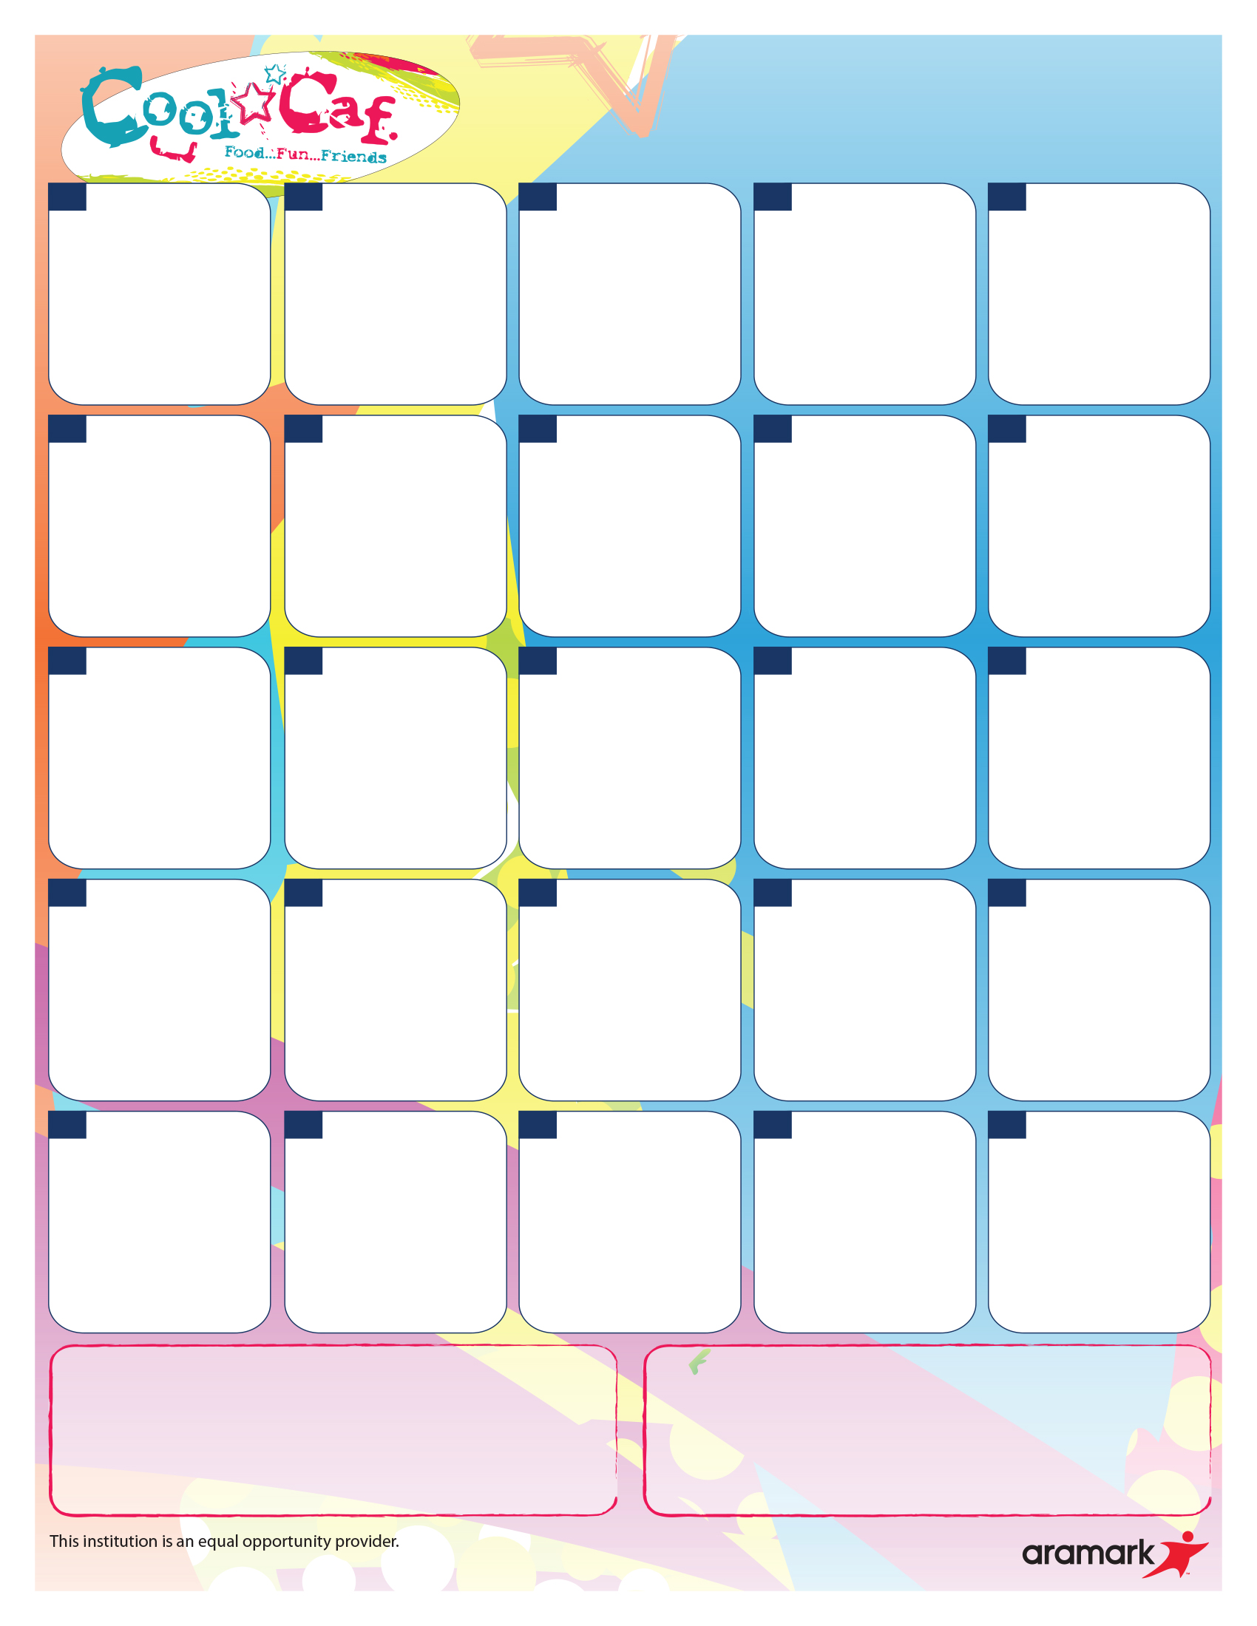

**Southfield Public Schools**

**Kennedy Lunch Menu**

**February 2019**

**Chicken Bowl with Mashed Potatoes & Corn**

**Dinner Roll (WG)**

**Chilled Applesauce**

**Fresh Whole Fruit**

**Half Day**

**Turkey & Gravy**

**Roasted Potatoes**

**Dinner Roll (WG)**

**Chilled Pears**

**Fresh Whole Fruit**

**Spaghetti w/Marinara**

**Green Beans**

**Dinner Roll (WG)**

**Apple Slices**

**Fresh Whole Fruit**

**No**

**School**

**Soft Beef Taco**

**Seasoned Corn**

**Flour Tortilla (WG)**

**Apple Slices**

**Fresh Whole Fruit**

**Cheeseburger**

**French Fries**

**Apple Slices**

**Fresh Whole Fruit**

**Chicken Alfredo w/Pasta**

**Broccoli**

**Dinner Roll (WG)**

**Chilled Applesauce**

**Fresh Whole Fruit**

**Chicken Tenders**

**Broccoli**

**Dinner Roll (WG)**

**Chilled Pears**

**Fresh Whole Fruit**

Hot Grilled Sandwiches

Milk (1% White, Chocolate, Strawberry)

**Grilled Chicken Patty**

**Green Peas**

**Chilled Peaches**

**Fresh Whole Fruit**

**Jets Pizza Day**

**Green Beans**

**Chilled Fruit Cocktail**

**Fresh Whole Fruit**

**No**

**School**

**Chicken Nuggets**

**Green Beans**

**Dinner Roll (WG)**

**Chilled Applesauce**

**Fresh Whole Fruit**

**Jets Pizza Day**

**Sweet Potato Tots**

**Chilled Fruit Cocktail**

**Fresh Whole Fruit**

**Jets Pizza Day**

**Roasted Potatoes**

**Chilled Fruit Cocktail**

**Fresh Whole Fruit**

**French Toast w/Turkey Sausage**

**Hash Brown**

**Chilled Peaches**

**Fresh Whole Fruit**

**Turkey Pot Pie**

**Peas & Carrots**

**Biscuit (WG)**

**Chilled Pears**

**Fresh Whole Fruit**

**Questions or comments?**

**Please call the Food**

**Service Department at**

**(248) 746-8683**

**Menus are subject to change without notice.**



**31**

**8**

**No**

**School**

**No**

**School**

**12**

**No**

**School**

**This institution is an equal opportunity provider.**

**25**

**26**

**27**

**28**

**1**

**18**

**19**

**20**

**21**

**22**

**15**

**14**

**13**

**11**

**7**

**6**

**5**

**4**